Project Specification:
AI Tool: Converting APIs to MCPs

Date of Submission: 09/10/2026
Supervisor: Paul Barry



Amelia Hamulewicz
C00296605

Table of Contents
Project Overview: 3
Background and Motivation: 3
Problem Statement: 4
Target Audience: 4
Main Features: 4
What I found from my Research: 5
Tech Stack: 5

Project Overview:
For my project, I will build a program that converts an API description into an MCP tool [1]. I will give the program an OpenAPI URL or file, and my python code will read the description and create MCP tools for GET, POST, PUT, and DELETE operations.
The main thing I want to demonstrate is that this conversion can be automated rather than requiring developers to manually create an MCP tool for every API operation.
For my first test, I will reuse a Java Project I made in second year of college. I will keep the parts of the code that are useful and add REST API endpoints for its Customer, Product, and Invoice CRUD functions.
Later in the project, I hope to test my program with a public OpenAPI source as an additional example.

Background and Motivation:
I first came across MCP (Model Context Protocol) during my internship. An MCP tool lets an AI access external tools and data sources. In other words, AI can do more than just answer questions in a chat. It can now perform different operations for you. For example, an AI could use a tool to retrieve or update information in another application when the user asks it to. See image below for more context.
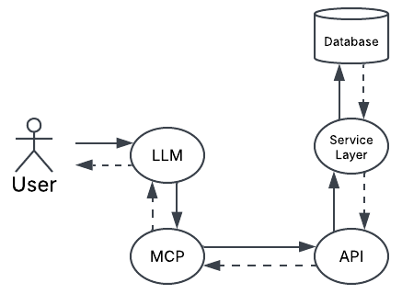
[MCP Flowchart, created by author]
This gave me the idea of looking at how existing REST APIs could be made available as MCP tools. Many APIs already have an OpenAPI description containing their endpoints, inputs and schemas, so my project will use this information as the starting point for generating MCP tools.

Problem Statement:
Developers with an existing REST API would normally need to create MCP tools for an AI to use it. My project will automate this using the API’s OpenAPI description.

Target Audience:
My main target audience are developers and students who already have a REST API and want to make it available to an AI through MCP without having to create every MCP tool manually.

Main Features:
- Add OpenAPI – The user can enter an OpenAPI URL or upload a JSON/YAML file
- Read OpenAPI – The program will read the API operations, inputs and other information from the OpenAPI specification.
- Generate MCP Tools – The program will automatically generate MCP tools from supported REST API operations.
- View Generated Tools – The developer can view the MCP tools that have been created.
- Manage Tools – The developer can edit the names and descriptions of generated tools.
- Connect Tools to REST API – When an MCP tool is used, it will send a request to the correct REST API endpoint and return the result.
- Developer Test Chat – The developer can test the generated tools with an LLM using a simple chat.
- Show Selected Tool – The developer can see which MCP tool the LLM selected.
- Show Tool Inputs – The developer can see the arguments that were passed to the MCP tool.
- Show API Request and Result – The developer can see which REST API endpoint was called and the response that was returned.
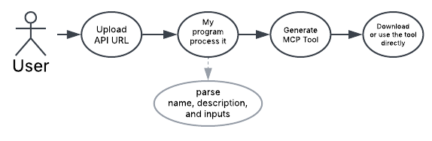
[Main feature flowchart, created by author]

What I found from my Research:
After researching, I found that API-to-MCP converters such as liblab, Postman and Speakeasy already exist [2–4]. To make my project different, I want API2MCP to be free, open-source and account-free.

Tech Stack:
Tool | What I will use it for
Python and an MCP SDK library | Python is commonly used for developing MCP servers and tools. I will use it to parse API documentation, create tool definitions and handle tool calls.
Java and proposed Spring Boot layer | Add REST endpoints to my existing second year project.
OpenAPI / Swagger | Describe the API operations and their inputs.
HTML / CSS / JavaScript | Build the simple website.
GitHub | Track my code and project changes
Compatible AI agent | Demonstrate AI tool use.

References:
- Model Context Protocol (2026) Build an MCP Server. Available at: https://modelcontextprotocol.io/docs/2026-07-28/develop/build-server (Accessed: 8 October 2026).
- liblab (2026) Generate MCP Server for Your API. Available at: https://liblab.com/docs/mcp/howto-generate-mcp-with-liblab (Accessed: 8 October 2026).
- Postman (n.d.) MCP Generator. Available at: https://www.postman.com/explore/mcp-generator (Accessed: 8 October 2026).
- Speakeasy (n.d.) Generate MCP Tools from OpenAPI. Available at: https://www.speakeasy.com/mcp/tool-design/generate-mcp-tools-from-openapi (Accessed: 8 October 2026).

